TCP 1 Reflection

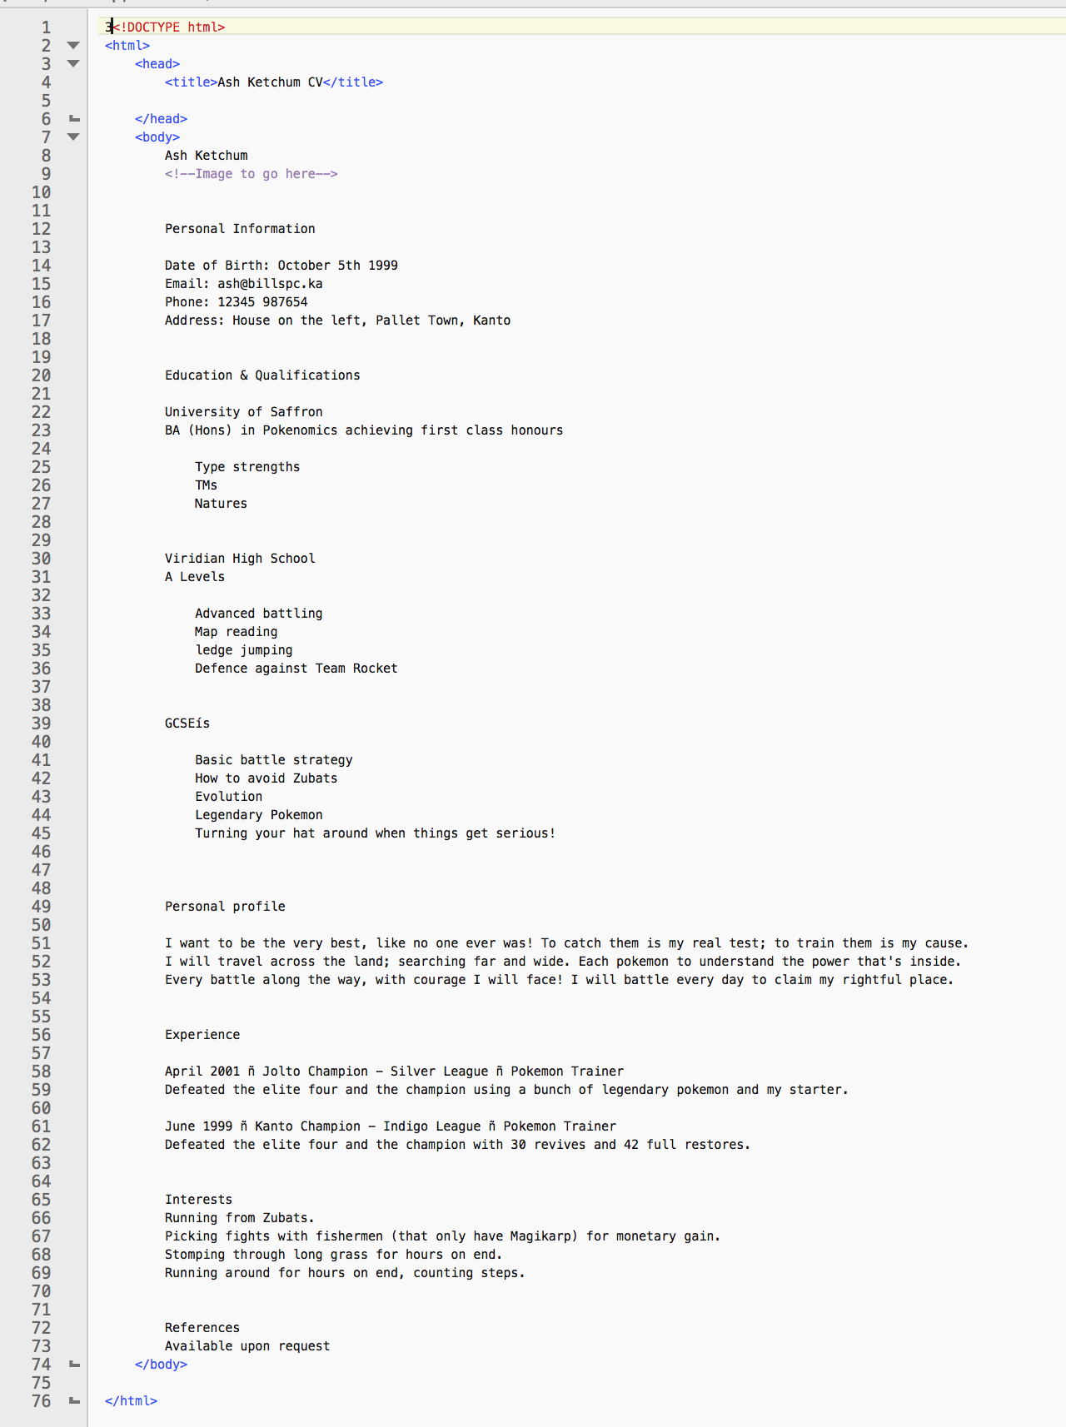

In TCP 1 I learnt about basic html tags and how to start a document, this was swiftly followed by the first task, editing a basic text webpage in html. we had to give the page structure by using different tags we had learned such as the break tag <b/> and the paragraph tag <p>.

The code snippets provided helped us to complete the task more quickly, I didn't find them too useful as the tags we were using were fairly basic and I found that after reading them more than once I didn't need to re-read them each time.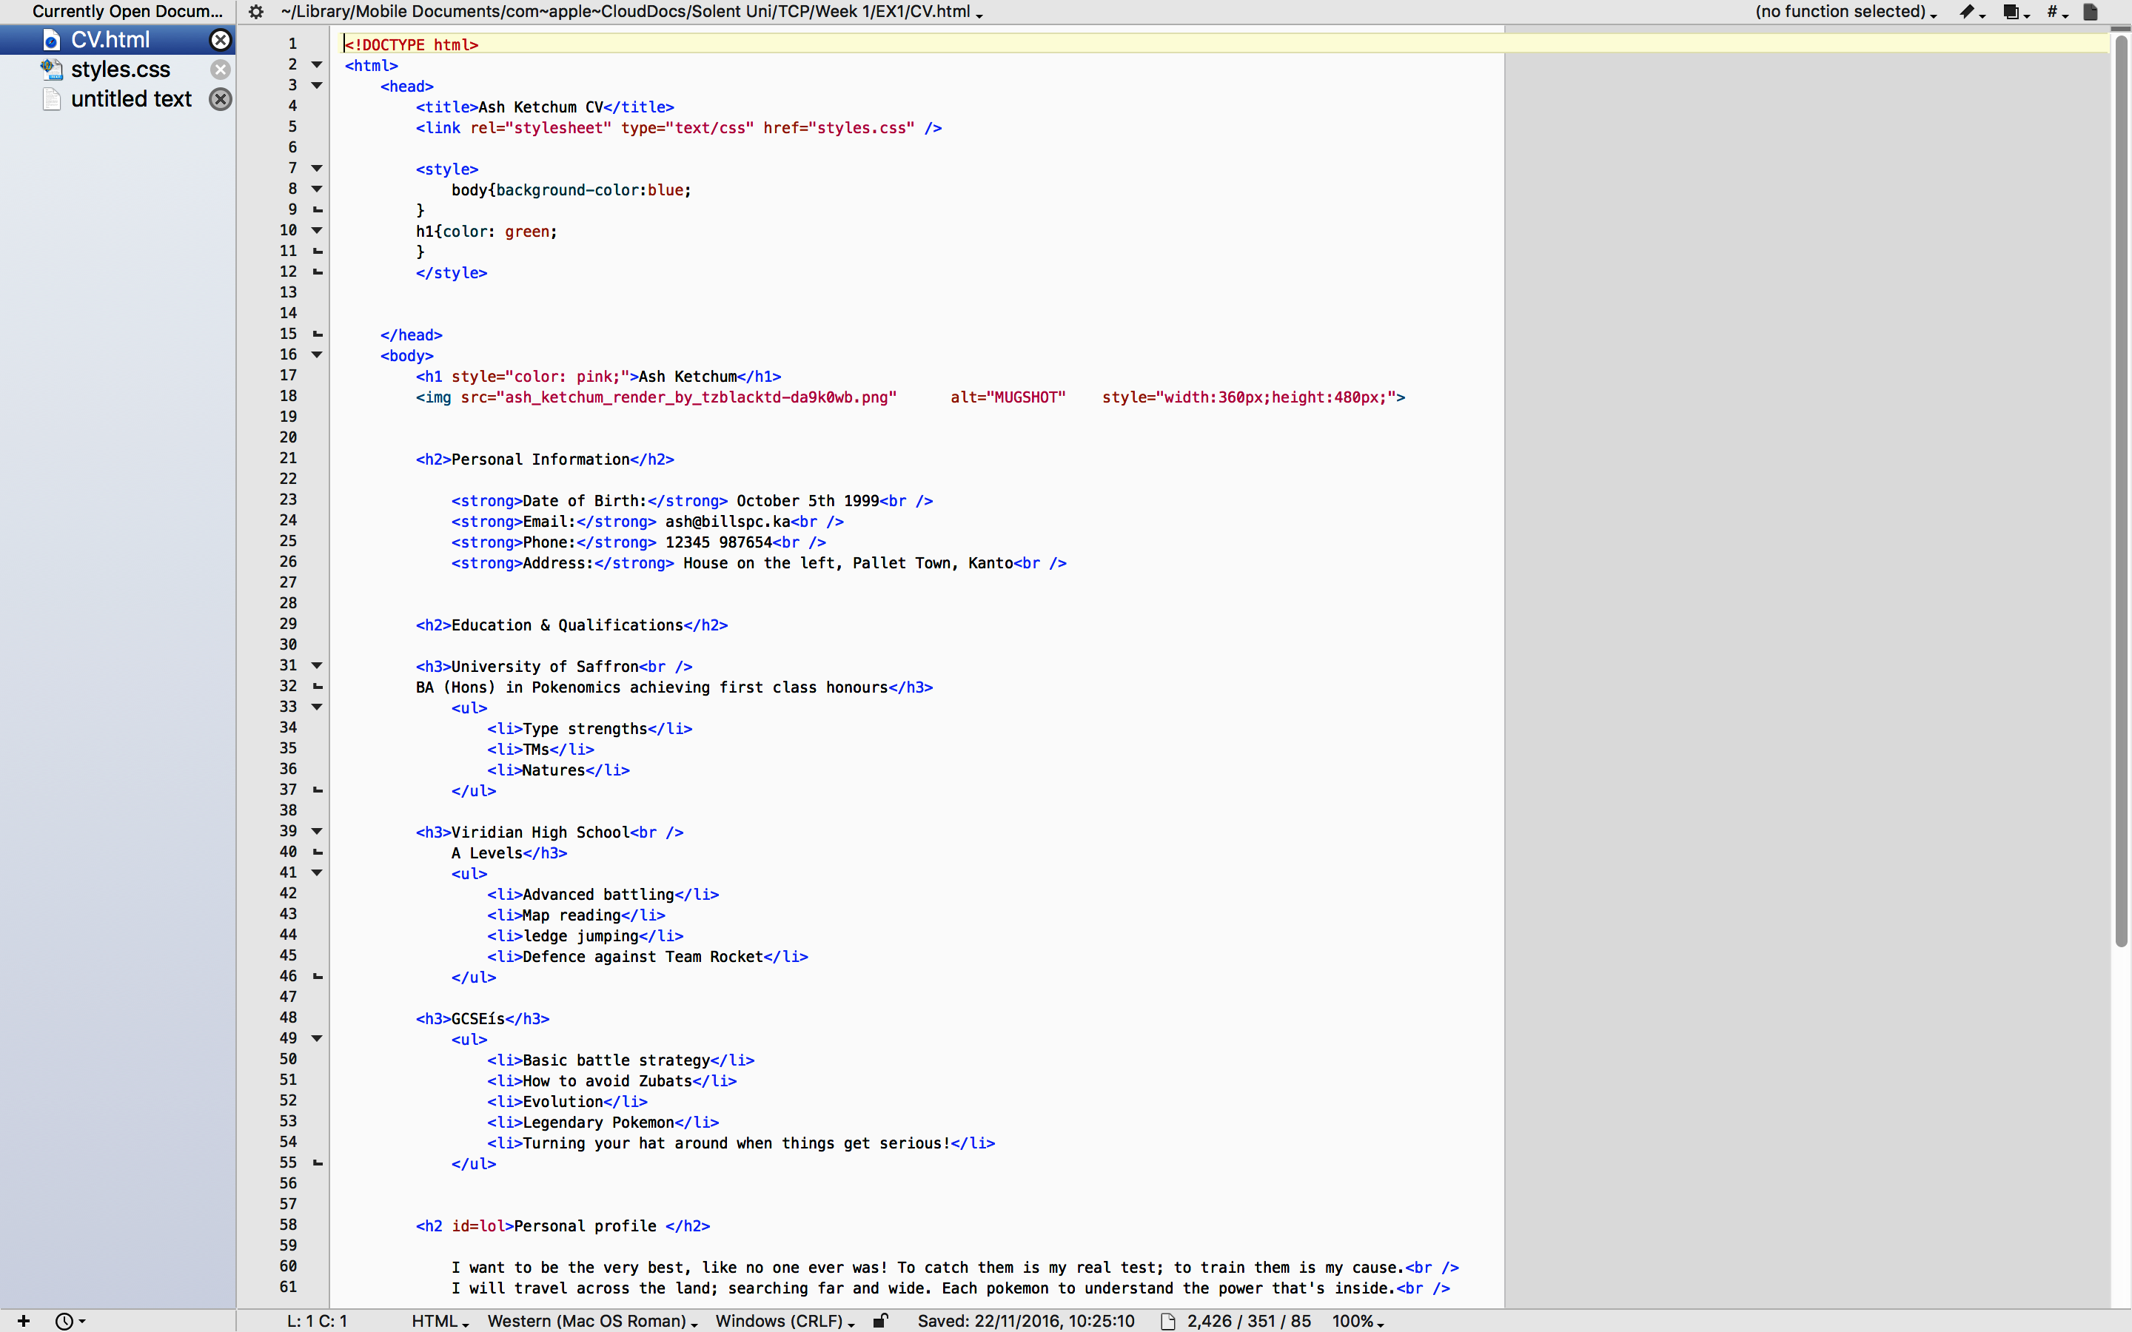

Moving on from the text tags we learnt the basics of tables, this then led to us to learn different tags for row and column holders.

This will help me in the progression of my knowledge of coding by allowing me to create tables that I can use for different page formatting and to an extent the page layout.

From these activities I have learnt about different ways of tagging sections of code that allows me to progress further in web development as well as having practical skills to progress in the group project.